ADVANCED INTERVENTIONAL PAIN CONSULTANTS Initial Consultation

Name _______________________________ Date of Birth _____________ Age _____

PRIMARY CARE DOCTOR ___________________ REFERRING PHYSICIAN _______________________

What is your MAIN PAIN COMPLAINT? ______________________________________________________________________

HISTORY OF PRESENT ILLNESS

When and how did the pain start?___________________________________________________________________________
_______________________________________________________________________________________________________
_______________________________________________________________________________________________________
_______________________________________________________________________________________________________

Where you involved in a motor vehicle accident? ___ Yes___ No___ Did you sustain a work related injury? ___Yes ___ No

Where is your pain located? How intense is your pain?
Draw in the diagram where your pain is located Circle the lowest and highest levels

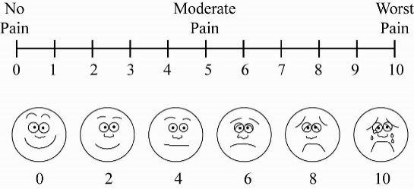
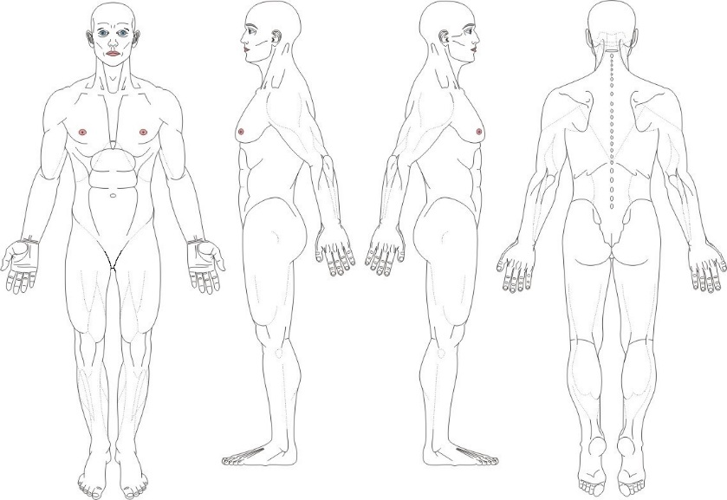

How do you best describe your pain?
___ Aching ___ Electrical ___ Stabbing ___ Sharp
___ Dull ___Throbbing ___ Shock-like ___ Burning

What is the pattern of your pain?
___ Constant ___ Intermittent
___ Mornings ___ Afternoons ___ Nights

Does the pain radiate to other areas? ___Yes ___No
If yes, where? ______________________________

Any associated symptoms? ___ Numbness ___ Tingling ___ Weakness ___ Muscle spasms ___ Others, __________________

What makes the pain worse? __________________________________________________________________________________

What makes the pain better? __________________________________________________________________________________

Overtime, is the pain getting? ___ Better ___ Worse ___ About the same

HOW DOES PAIN AFFECT YOUR QUALITY OF LIFE? Explain

___ Family life/marriage _____________________________________________________________________
___ Ability to work _________________________________________________________________________
___ Ability to sleep _________________________________________________________________________
___ Activities of daily living ___________________________________________________________________
___ Sex life ________________________________________________________________________________

What MEDICATIONS have you used in the past for pain relief?

Opioids ___ Morphine (Avinza, Kadian, MS Contin)
___ Oxycodone (Oxycontin, Percocet, Percodan, Endocet)
___ Codeine (Tylenol #3 or #4)
___ Hydrocodone (Vicodin, Norco, Vicoprofen, Lortab, Lorcet, Zohydro)
___ Tramadol (Ultram)
___ Hydromorphone (Dilaudid, Exalgo)
___ Oxymorphone (Opana)
___ Fentanyl (Duragesic, Fentora, Actiq)
___ Tapentadol (Nucynta)
___ Buprenorphine (Butrans, Subaxone, Subutex)
___ Methadone (Dolophine)

Anti-inflammatories ___ Ibuprofen (Motrin, Advil) ___Naproxen (Naprosyn, Anaprox, Naprelan, Aleve)
___ Meloxicam (Mobic) ___Piroxicam (Feldane) ___Celecoxib (Celebrex) ___Etodolac
___ Diclofenac (Voltaren) ___Nabumetone (Relafen)

Muscle relaxants ___ Carisoprodol (Soma), ___Baclofen, ___Cyclobenzaprine (Flexeril, Amrix)
___Metaxalone (Skelaxin), ___Tizanidine (Zanaflex), ___Methacabamol (Robaxin)

Anticonvulsants ___ Gabapentin (Neurontin), ___Pregabalin (Lyrica), ___Topiramate (Topamax)
___ Carbamazepine (Tegretol), ___Oxcarbazepine (Trileptal), ___Phenytoin (Dilatin)
___ Lamotrigine (Lamictal)

Antidepressants ___ Duloxetine (Cymbalta) ___Venalafaxine (Effexor) ___Desvenlafaxine (Prestiq),
___ Milnacipran (Savella) ___Amitriptyline (Elavil) ___Nortriptyline (Pamelor) ___Fluoxitine (Prozac)
___ Citalopram (Celexa) ___Sertraline (Zoloft) ___Trazadone (Desyrel) ___Mitarzipine (Remeron),
___ Bupropion (Wellbutrin)

Benzodiazepines ___ Alprazolam (Xanax) Lorazepam (Ativan) Diazepam (Valium) Clonazepam (Klonopin)

Sleep aids ___ Zolpidem (Ambien) Eszopiclone (Lunesta) ___ Zaleplon (Sonata) ___ Ramelteon (Rozeram)

Have you been treated by a pain management doctor(s) before? ___ No ___ Yes
List the doctor(s) name(s) and dates? ____________________________________________________________________

Have you had pain injections in the past? ___ No ___ Yes
If yes, what type of injections and date of the injections? _____________________________________________________

Have you had a spinal cord stimulator trial and/or a permanent implant placed? ___ No ___ Yes
If yes, date __________________ Who performed the placement?____________________________

Do you have a pain pump implanted? ___ No ___ Yes
If yes, date __________________ Who performed the placement? ___________________________

OTHER TREATMENT MODALITIES Date Helped No change

___ Exercise _______________ ____ ____
___ Acupuncture _______________ ____ ____
___ Massage _______________ ____ ____
___ Hot packs _______________ ____ ____
___ Cold packs _______________ ____ ____
___ TENS units _______________ ____ ____
___ Yoga _______________ ____ ____
___ Holistic _______________ ____ ____
___ Spiritual _______________ ____ ____
___ Physical therapy
Standard _______________ ____ ____
Aquatic _______________ ____ ____
___ Chiropractor _______________ ____ ____
___ Psychological
Counseling _______________ ____ ____
Biofeedback _______________ ____ ____
Cognitive _______________ ____ ____

PAST SURGICAL HISTORY List all past surgeries and dates

1) ____________________________________________________________________________________
2) ____________________________________________________________________________________
3) ____________________________________________________________________________________
4) ____________________________________________________________________________________
5) ____________________________________________________________________________________
6) ____________________________________________________________________________________

PAST MEDICAL HISTORY

___ Heart disease ___ Congestive heart failure ___ Coronary artery disease ___ Heart attacks
___ Bypass surgery ___ Coronary stents
___ Hypertension _______________________________________________________________________
___ Stroke ___Transient ischemic attack_____________________________________________________
___ Diabetes ___________________________________________________________________________
___Thyroid disease ______________________________________________________________________
___ COPD ___ Asthma ___ Emphysema ___ Obstructive Sleep Apnea ___________________________
___ Liver disease ___ Cirrhosis ___ Hepatitis ________________________________________________
___ Seizures ____________________________________________________________________________
___ Cancer _____________________________________________________________________________
___ Fibromyalgia ___ Rheumatoid arthritis ___ Ankylosing Spondylitis ___ Lupus ___Psoriatic arthritis
___ Osteoarthritis ___ Osteoporosis ___ Fibromyalgia ________________________________________
___ Multiple sclerosis ____________________________________________________________________
___ Headaches _________________________________________________________________________
___ Depression ___ Anxiety ___ Bipolar disorder ____________________________________________
___ HIV Positive _________________________________________________________________________
___ Others ______________________________________________________________________________

Are you ALLERGIC or sensitive to any medications? ___ No ___ Yes List ___________________________________
________________________________________________________________________________________________

List all MEDICATIONS FOR PAIN are you currently taking. Include dose, times per day taken, and name of prescribing doctor

- ________________________________________________ 4) _______________________________________________
- ________________________________________________ 5) _______________________________________________
- ________________________________________________ 6) _______________________________________________

List all OTHER MEDICATIONS you are currently taking. Include dose and times per day taken

- ________________________________________________ 6) _______________________________________________
- ________________________________________________ 7) _______________________________________________
- ________________________________________________ 8) _______________________________________________
- ________________________________________________ 9) _______________________________________________
- ________________________________________________ 10) _______________________________________________

Do you take any blood thinners? ___ Plavix ___ Coumadin ___ Lovenox ___ Heparin ___ Aspirin ___ Digabatran (Vigabatin)
___ Apixoban (Elquis) ___ Rivaroxaban (Xarelto) ___ Edoxaban (Lixiana) ___ Alteplase (Aclilyse) ___ Ticlopidine (Ticlid)

SOCIAL HISTORY

Are you employed? ___ No ___Yes, what is your occupation? _______________________ Are you disabled? ___No ___Yes

Marital status: ___ Married ___ Single ___ Divorced ___ Separated How many children do you have? ____

Do you drink? ___ No ___ Yes How many drinks per week? _________________________

Do you smoke? ___ No ___ Yes How many cigarettes or packs per day? ________________

Do you currently use or have you ever used illicit drugs? ___ No ___ Yes, which ones? ___________________________

Have you ever abused narcotics or prescription medications? ___ No ___ Yes, explain _______________________________

Are you under the care of a Psychiatrist or Psychologist? ___ No ___ Yes
If yes, what is the name of your Psychiatrist? ____________________________ Psychologist? __________________________

Describe any significant traumatic events in your life ____________________________________________________________
________________________________________________________________________________________________________

FAMILY HISTORY
Does anyone in your family have a history of back or neck pain, depression, anxiety, or substance abuse (alcohol or drugs)?
___ No ___ Yes, explain ___________________________________________________________________________________
________________________________________________________________________________________________________

REVIEW OF SYSTEMS Circle all that apply ____ No problems

1. General Weight gain or loss, unexplained hair loss, fever or chills, low energy, too sleepy, too tired
2. ENT Eye pain, vision problems (blurred vision, loss of vision), hearing loss, swollen glands in neck, sore throat/pain when swallowing, dental problems
3. Cardiovascular Chest pain (sharp, crushing, or heaviness), heart racing (palpitations), fainting spells, shortness of breath, swelling of legs (edema)
4. Respiratory Shortness of breath, cough/coughing up blood
5. Gastrointestinal Increased appetite, decreased appetite, stomach pain, nausea/vomiting, diarrhea, constipation
6. Genitourinary Pain when passing water (urination), blood in urine, urinating more than usual (day and/or night), bladder Infection, pain during sex, changes in sex drive (libido)
7. Musculoskeletal Limited motion of arms or leg, joint pain, swelling/redness, numbness, tingling, or weakness in arms or legs
8. Neurological Arm/leg weakness, new headaches, problems with memory or speech, tremors
9. Psychiatric Sadness, stress, anxious, seeing or hearing things, suicidal thoughts, feeling down, insomnia
10. Endocrine Weight gain/loss, thirsty all the time, cannot stand temperature changes (heat/cold)
11. Lymph Swollen glands (armpits or groin)
12. Skin Rash (palm of hands, sole of feet), changes in skin, sores or rash on skin
13. Allergies Hives/skin rashes, allergic reaction to foods

SLEEP APNEA SURVEY ___ Excessive loud snoring ___ Gasping or choking for breath while sleeping ___ Tired after sleeping
___ Falling asleep and daytime tiredness ___ Witnessed respiratory pauses ___ Night time difficulties
___ Have high blood pressure

I attest that ALL information I have provided is accurate and factual, and I can provide supporting information.

Patient‘s Signature __________________________________

