ADVANCED INTERVENTIONAL PAIN CONSULTANTS Follow Up Visit
Name _______________________________ Date of Birth __________ Age ____ Date ____________

PRIMARY CARE DOCTOR ____________________ REFERRING PHYSICIAN ________________________

WHAT IS YOUR MAIN PAIN COMPLAINT TODAY? _________________________________________________________________

HISTORY OF PRESENT ILLNESS

How are you doing since your last visit? ___ Improved ___ No change ___ Worse Explain: ______________________________

Where is your pain located? Draw How intense is your pain? Circle the lowest and highest
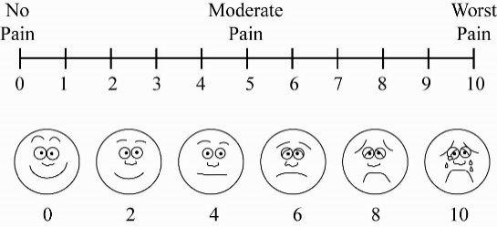

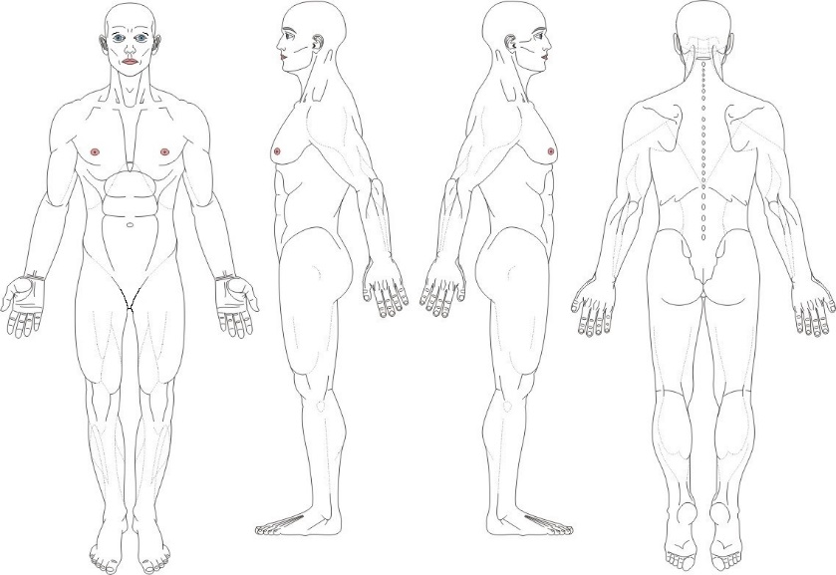

How do you best describe your pain?
___Dull ___Electrical ___Stabbing ___Burning
___Aching ___Throbbing ___Shock-like ___Sharp

What is the pattern of your pain?
___ Constant ___ Intermittent
___ Mornings ___ Afternoons ___ Nights

Does the pain radiate to other areas? ___Yes ___No
If yes, where? ____________________________

Any associated symptoms? ___ Numbness ___ Weakness ___ Muscle spasms ___ Tingling

Has the TREATMENT you are receiving improved any of the following aspects of your life?

Activities of daily living ___ Yes ___ No Relations with people ___ Yes ___ No
Ability to work ___ Yes ___ No Sleeping/rest ___ Yes ___ No
Family life ___ Yes ___ No Depression/anxiety ___ Yes ___ No

Overall, has the treatment you are receiving made a positive change in your condition? ___ Yes ___ No

Have the medications we prescribed caused any of the following SIDE EFFECTS? (Circle all that apply)
Nausea Vomiting Itchiness Constipation Drowsiness Sweating Loss of libido Weight gain Swelling

List all OTHER MEDICATIONS you are currently taking. Include pain creams. Include dose (mg) and how many pills you take per day
- ________________________________________________ 6) _______________________________________________
- ________________________________________________ 7) _______________________________________________
- ________________________________________________ 8) _______________________________________________
- ________________________________________________ 9) _______________________________________________
- ________________________________________________ 10) _______________________________________________

Are you ALLERGIC or sensitive to any medications? ___ No ___ Yes List ___________________________________________

Do you take any blood thinners? ___ No ___ Yes

OPIOID ATTESTATION

___ I have used all medications prescribed to me exactly as prescribed.
___ I have reported all side effects to my physician.
___ I have not sold, given to someone else, or otherwise transferred my medications to anyone.
___ I have safeguarded my medications from theft.
___ I have not received, accepted, taken, or otherwise used any other opioid medications (narcotics) from any other source,
including from other physicians.
___ I have not received, accepted, taken, or otherwise used any illegal drugs.
___ I have not used alcohol while taking my opioid medications (narcotics).

I attest and certify that all of the following statements are true and factual

Patient‘s Signature _________________________________

MEDICAL HISTORY Has your medical history changed since your last visit, including ER visits and hospitalizations? ___No ___Yes
Explain __________________________________________________________________________________________________
________________________________________________________________________________________________________
________________________________________________________________________________________________________

SURGICAL HISTORY Have you had surgery since your last visit? ___ No ___ Yes, explain _______________________________
_________________________________________________________________________________________________________
_________________________________________________________________________________________________________

Are you doing PHYSICAL THERAPY? ___ No ___ Yes

Are you under psychiatric care or receiving psychological counseling? ___ No ___ Yes

REVIEW OF SYSTEMS Circle all that apply ____ No new problems

1. General Weight gain or loss, unexplained hair loss, fever or chills, low energy, too sleepy, too tired
2. ENT Eye pain, vision problems (blurred vision, loss of vision), hearing loss, swollen glands in neck, sore throat/pain when swallowing, dental problems
3. Cardiovascular Chest pain (sharp, crushing, or heaviness), heart racing (palpitations), fainting spells, shortness of breath, swelling of legs (edema)
4. Respiratory Shortness of breath, cough/coughing up blood
5. Gastrointestinal Increased appetite, decreased appetite, stomach pain, nausea/vomiting, diarrhea, constipation
6. Genitourinary Pain when passing water (urination), blood in urine, urinating more than usual (day and/or night), bladder Infection, pain during sex, changes in sex drive (libido)
7. Musculoskeletal Limited motion of arms or leg, joint pain, swelling/redness, numbness, tingling, or weakness in arms or legs
8. Neurological Arm/leg weakness, new headaches, problems with memory or speech, tremors
9. Psychiatric Sadness, stress, anxious, seeing or hearing things, suicidal thoughts, feeling down, insomnia
10. Endocrine Weight gain/loss, thirsty all the time, cannot stand temperature changes (heat/cold)
11. Lymph Swollen glands (armpits or groin)
12. Skin Rash (palm of hands, sole of feet), changes in skin, sores or rash on skin
13. Allergies Hives/skin rashes, allergic reaction to foods

I attest that all of the information I have provided is accurate and factual, and I can provide supporting information.

Patient‘s Signature __________________________________

