**ADVANCED INTERVENTIONAL PAIN CONSULTANTS Initial Consultation**

**Name** _______________________________ **Age** _____  **Date of Birth** _____________ **Date** ________________

**REFERRING PHYSICIAN** ___________________________ **PRIMARY CARE DOCTOR** _____________________________

What is your **main pain complaint**? Circle what applies

**Low-back Mid-back Neck Head Joints** Hip Knee Shoulder **Muscles** **Other**_________________________

**HISTORY OF PRESENT ILLNESS**

**When** did the pain start? How many days/months/years ago or date _________________________________________

Where you involved in a **motor vehicle accident**? Yes___ No___ Did you sustain a **work related injury**? Yes___ No___

**How** did the pain start? Explain _______________________________________________________________________ _________________________________________________________________________________________________ ______________________________________________________________________________________________­­­­___

**Where** is your pain located? Marked in the diagram where your pain is present.

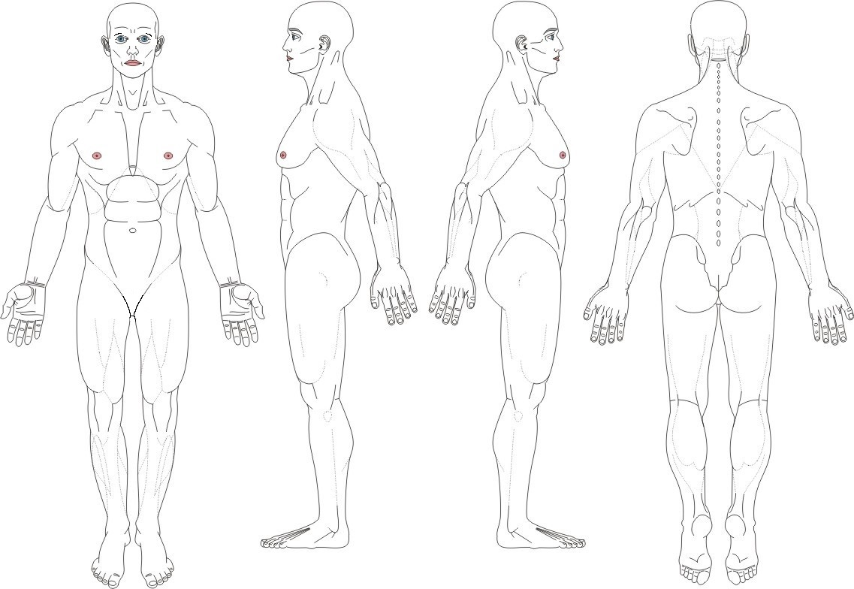

If you are being consulted for **headaches**, mark which areas are affected and where the pain radiates

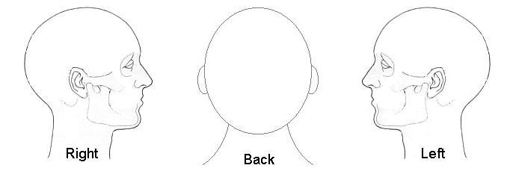

How many headaches do you get per week? _____ How many per month? _____

**Numeric Pain Scale**

**How intense** is your pain? Circle the lowest level and the highest level

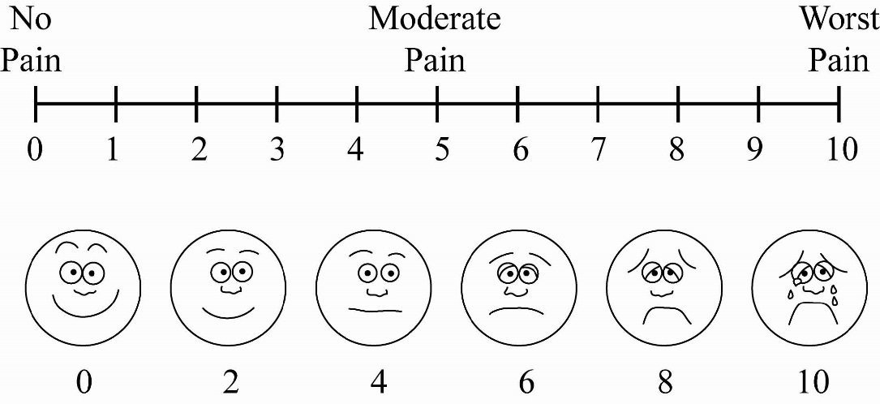

How do you best **describe** your pain? What is the **pattern** of your pain?

Dull Electrical Constant

Sharp Burning Intermittent

Stabbing Shock-like Mornings Afternoons Nights

Aching Throbbing

Any **associated symptoms** ___ Numbness ___ Tingling ___ Weakness ___ Muscle spasms

Does the pain **radiate** to other areas? Yes No If yes, where does the pain **radiate**? _________________________

What makes the pain **worse**? __________________________________________________________________________

What makes the pain **better**? __________________________________________________________________________

Overtime, is the pain getting? Better Worse About the same

What **medications** have you used in the past for pain relief?

Opioids ___ Morphine (Avinza, Kadian, MS Contin)

___ Oxycodone (Oxycontin, Percocet, Percodan, Endocet)

___ Codeine (Tylenol #3 or #4)

___ Hydrocodone (Vicodin, Norco, Vicoprofen, Lortab, Lorcet, Zohydro)

___ Tramadol (Ultram)

___ Hydromorphone (Dilaudid, Exalgo)

___ Oxymorphone (Opana)

___ Fentanyl (Duragesic, Fentora, Actiq)

___ Tapentadol (Nucynta)

___ Buprenorphine (Butrans, Subaxone, Subutex)

___ Methadone (Dolophine)

Anti-inflammatories ___ Ibuprofen (Motrin, Advil), Naproxen (Naprosyn, Anaprox, Naprelan, Aleve), Meloxicam (Mobic), Piroxicam (Feldane), Celecoxib (Celebrex), Etodolac, Doclofenac (Voltaren)

Nabumetone (Relafen)

Muscle relaxants ___ Carisoprodol (Soma), Baclofen, Cyclobenzaprine (Flexeril, Amrix),

Metaxalone (Skelaxin), Tizanidine (Zanaflex), Methacabamol (Robaxin)

Anticonvulsants ___ Gabapentin (Neurontin), Pregabalin (Lyrica), Topiramate (Topamax), Carbamazepine (Tegretol), Oxcarbazepine (Trileptal), Phenytoin (Dilatin), Lamotrigine (Lamictal)

Antidepressants ___ Duloxetine (Cymbalta), Venalafaxine (Effexor), Desvenlafaxine (Prestiq), Milnacipran (Savella), Amitriptyline (Elavil), Nortriptyline (Pamelor), Fluoxitine (Prozac), Citalopram (Celexa), Sertaline (Zoloft), Trazadone (Desyrel), Mitarzipine (Remeron), Bupropion (Wellbutrin)

Benzodiazepines ___ Alprazolam (Xanax), Lorazepam (Ativan), Diazepam (Valium), clonazepam (Klonopin)

Sleep aids ___ Zolpidem (Ambien), Eszopiclone (Lunesta), Zaleplon (Sonata), Ramelteon (Rozeram),

over the counter sleep aids

Have you been treated by a **pain management doctor**(s) before? ___ No ___ Yes

List the doctor(s) name(s) and dates? ____________________________________________________

____________________________________________________

Have you had any **pain injections** done? ___ No ___ Yes If yes, what type of injections and date of the injections?

_________________________________________________________

_________________________________________________________

_________________________________________________________

Have you had a **spinal cord stimulator trial**? ___ No ___ Yes

If yes, when? ______________ Who performed the trial? _______________________________

Have you had a **spinal cord stimulator permanently placed**? ___ No ___ Yes

If yes, when? ______________ Who performed the placement?__________________________

Have you had a **pain pump** implanted? ___ No ___ Yes

If yes, when? ______________ Who performed the placement? __________________________

Have you been treated by a **spine surgeon**, **neurosurgeon** or **orthopedic surgeon**? ___ No ___ Yes

What is the name of the doctor(s) and dates? ______________________________________________

______________________________________________

______________________________________________

Have you had **neck or back surgery**? ___ No ___ Yes

What type of surgery and dates of the surgery? 1) __________________________________________

2) __________________________________________

3) __________________________________________

What **other treatment modalities** have you tried?

**Date Helped No change**

___ Acupuncture _______________ ____ ____

___ Massage _______________ ____ ____ ___ Hot packs _______________ ____ ____ ___ Cold packs _______________ ____ ____

___ Physical therapy

Standard _______________ ____ ____

Aquatic _______________ ____ ____

Traction _______________ ____ ____

___ TENS units _______________ ____ ____

**Date Name Helped No change**

___ Chiropractor _______________ _________________________ ____ ____

___ Psychological

Counseling _______________ _________________________ ____ ____

Biofeedback _______________ _________________________ ____ ____

Cognitive _______________ _________________________ ____ ____

How does **pain affect** your life style? Explain

___ Family life/marriage ________________________________________________________________

___ Ability to work _____________________________________________________________________

___ Ability to sleep _____________________________________________________________________

___ Activities of daily living ______________________________________________________________

___ Sex life ___________________________________________________________________________

**PAST SURGICAL HISTORY** List all surgeries and dates

1) ________________________________________ 4) ________________________________________

2) ________________________________________ 5) ________________________________________

3) ________________________________________ 6) ________________________________________

**PAST MEDICAL HISTORY**

Heart disease ___ Congestive heart failure ___ Coronary artery disease ___ Heart attacks

___ Bypass surgery ___ Coronary stents

Hypertension ________________________________________________________________________

Stroke Transient ischemic attack_______________________________________________________

Diabetes ____________________________________________________________________________

Thyroid disease ______________________________________________________________________

COPD Asthma Emphysema ________________________________________________________

Liver disease Cirrhosis Hepatitis _____________________________________________________

Seizures ____________________________________________________________________________

Cancer _____________________________________________________________________________

Fibromyalgia Rheumatoid arthritis Ankylosing Spondylitis Lupus Psoriatic arthritis

Osteoarthritis Osteoporosis Fibromyalgia _____________________________________________

Multiple sclerosis _____________________________________________________________________

Headaches __________________________________________________________________________

Depression Anxiety Bipolar disorder _________________________________________________

Others ______________________________________________________________________________

Are you **ALLERGIC** or sensitive to any medications? ___ No ___ Yes List _____________________________________

__________________________________________________________________________________________________

What **MEDICATIONS or TOPICAL CREAMS for PAIN** are you currently using? Include dosage and times per day taken

1. ______________________________________________
2. ______________________________________________
3. ______________________________________________
4. ______________________________________________
5. ______________________________________________

List all other **MEDICATIONS** are you currently taking. Include dose and times per day taken

1. ______________________________________________
2. ______________________________________________
3. ______________________________________________
4. ______________________________________________
5. ______________________________________________
6. ______________________________________________
7. ______________________________________________
8. ______________________________________________
9. ______________________________________________
10. ______________________________________________

Do you take any of the following **blood thinners**? ___ Plavix ___ Coumadin ___ Lovenox ___ Heparin

___ Aspirin ___ Digabatran (Vigabatin) ___ Apixoban (Elquis) ___ Rivaroxaban (Xarelto) ___ Edoxaban (Lixiana) ___ Alteplase (Aclilyse) ___ Ticlopidine (Ticlid)

**SOCIAL HISTORY**

Are you employed? ___ No ___ Yes Occupation _______________________________________

Are you disabled? ___ No ___ Yes Since when? ________________________

Marital status: ___ Married ___ Single ___ Divorced ___ Separated

How many children do you have? ____ What are their ages? _______________________________

Do you drink? ___ No ___ Yes How many drinks per week? _________________________

Do you smoke? ___ No ___ Yes How many cigarettes or packs per day? ________________

Do you smoke marijuana? ___ No ___ Yes

Do you currently use or have you ever used illegal drugs ___ No ___ Yes

Have you ever abused narcotics or prescription medications? ___ No ___ Yes, explain _________________________

Are you under the care of a psychiatrist or psychologist? ___ No ___ Yes

If yes, what is the name of your psychiatrist? ____________________________________________

Describe any significant traumatic events in your life ______________________________________________________

__________________________________________________________________________________________________

__________________________________________________________________________________________________

**FAMILY HISTORY**

Does anyone in your family have a history of back or neck pain, depression, anxiety, or substance abuse (alcohol or drugs)? ___ No ___ Yes

If yes, explain __________________________________________________________________________________

______________________________________________________________________________________________

**REVIEW OF SYSTEMS Circle all that apply** ____ No problems

**1. General**  Weight gain or loss, unexplained hair loss, fever or chills, low energy, too sleepy

**2. Eyes/ Ears/Nose/Throat**  Eye pain, vision problems (blurred vision, loss of vision), hearing loss, swollen glands in neck, sore throat/pain when swallowing, dental problems

**3. Cardiovascular**  Chest pain (sharp, crushing, or heaviness), heart racing (palpitations), fainting spells, shortness of breath, swelling of legs (edema)

**4. Respiratory** Shortness of breath, cough/coughing up blood

**5. Gastrointestinal**  Increased appetite,decreased appetite, stomach pain, nausea/vomiting, diarrhea, constipation

**6. Genitourinary**   Pain when passing water (urination), blood in urine, urinating more than usual (day and/or night), bladder Infection,pain during sex, changes in sex drive (libido)

**7. Musculoskeletal** Limited motion of arms or leg, joint pain, swelling/redness, numbness, tingling, or weakness in arms or legs

**8. Neurological**  Arm/leg weakness,new headaches, problems with memory or speech, tremors

**9. Psychiatric**  Sadness, stress, seeing or hearing things, suicidal thoughts, feeling down, insomnia

**10. Endocrine**  Weight gain/loss,thirsty all the time, cannot stand temperature changes (heat/cold)

**11. Lymph**  Swollen glands (armpits or groin)

**12. Skin** Rash (palm of hands, sole of feet), changes in skin, sores or rash on skin

**13. Allergies**  Hives/skin rashes, allergic reaction to foods

I attest that ALL information I have provided is accurate and factual, and I can provide supporting information.

**Patient‘s Signature** __________________________________